Title page

Put English Title Here

Daehan Kim¹⁾, Daehan Lee²⁾, Daehan Park^{3)*}

1) Affiliation of author1

2) Affiliation of author2

3) Affiliation of author3

*Corresponding author
Daehan Park
Affiliation of corresponding author
E-mail :
Tel : (02)123-4567 Fax : (02)123-9876

Key words : Key word, Key word, Key word, Key word, Key word, Key word

Put the Title Here (Times New Roman 15pt)
Daehan Kim¹⁾, Daehan Lee²⁾, Daehan Park^{3)*} (Times New Roman 10pt)

Key words : Key word, Key word, Key word, Key word, Key word, Key word

Abstract : (Times New Roman 9pt, 200-300words) Put Abstract here. Put Abstract here. Put Abstract here. Put Abstract here. Put Abstract here.Put Abstract here. Put Abstract here. Put Abstract here. Put Abstract here. Put Abstract here. Put Abstract here. Put Abstract here. Put Abstract here. Put Abstract here. Put Abstract here. Put Abstract here. Put Abstract here. Put Abstract here. Put Abstract here. Put Abstract here. Put Abstract here. Put Abstract here. Put Abstract here. Put Abstract here. Put Abstract here. Put Abstract here. Put Abstract here. Put Abstract here. Put Abstract here. Put Abstract here. Put Abstract here. Put Abstract here. Put Abstract here. Put Abstract here. Put Abstract here. Put Abstract here. Put Abstract here. Put Abstract here. Put Abstract here. Put Abstract here. Put Abstract here. Put Abstract here. Put Abstract here. Put Abstract here. Put Abstract here. Put Abstract here. Put Abstract here. Put Abstract here. Put Abstract here. Put Abstract here. Put Abstract here. Put Abstract here. Put Abstract here. Put Abstract here. Put Abstract here. Put Abstract here. Put Abstract here. Put Abstract here. Put Abstract here. Put Abstract here. Put Abstract here. Put Abstract here. Put Abstract here. Put Abstract here. Put Abstract here. Put Abstract here. Put Abstract here. Put Abstract here. Put Abstract here. Put Abstract here. Put Abstract here. Put Abstract here. Put Abstract here. Put Abstract here. Put Abstract here. Put Abstract here. Put Abstract here. Put Abstract here. Put Abstract here. Put Abstract here. Put Abstract here. Put Abstract here. Put Abstract here. Put Abstract here.
Nomenclature

V : wind speed, m/s
D : rotor diameter, m

subscript

WTGS : wind turbine generator system
L,R : left, right
(The description for Nomenclature and Subscripts should be in lower cases)

1. Introduction
(Times New Roman 11pt)

(Times New Roman 9pt) Put Introduction here. Put Introduction here. Put Introduction here. Put Introduction here. Put Introduction here. Put Introduction here. Put Introduction here. Put Introduction here. Put Introduction here. Put Introduction here. Put Introduction here. Put Introduction here. Put Introduction here. Put Introduction here. Put Introduction here. Put Introduction here. Put Introduction here. Put Introduction here. Put Introduction here. Put Introduction here. Put Introduction here. Put Introduction here. Put Introduction here. Put Introduction here. Put Introduction here. Put Introduction here. Put Introduction here. Put Introduction here. [1]
References should be marked in the form of contents of citation [1], with Arabic numeral in a square bracket

* Corresponding author
E-mail :
Tel : (02)123-4567 Fax : (02)123-9876
2. Section Title

Put the content. Put the content. Put the content.

2.1 Subsection Title (10pt)
2.2.1 Subsubsection Title (9pt)
1) Put the content.
① Put the content.
a. Put the content.
b. Put the content. [2]

3. Section Title

Put the content. Put the content. Put the content.

3.1 Subsection Title
Put the content. Put the content. Put the content. Put the content. Put the content. Put the content. Put the content. Put the content. Put the content. Put the content. Put the content. Put the content.
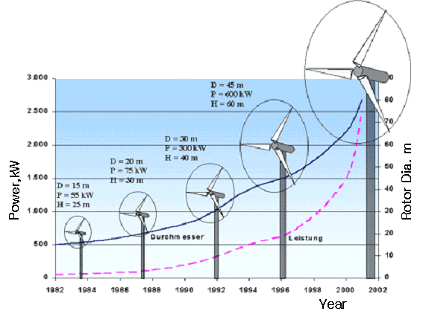
Ex) Fig. 1. Put the title here

3.2 Subsection Title
Put the content.

Ex) Table 1. Put the title here

3.2.1 Subsubsection Title
Put the content. Put the content. Put the content. Put the content. Put the content. Put the content. Put the content.
$P=\frac{1}{2}ρv^{3}A$ [W] (1)

3.2.2 Subsubsection Title
Put the content. Put the content. Put the content. Put the content. Put the content. Put the content. Put the content.

4. Conclusions

Put Conclusions here.

Acknowledgment

This work was supported by *****.

References
(Times New Roman 9pt)
* Mark the reference number in [] in the manuscript.
* References should be listed in the last part of the manuscript with the order of what they appear in the manuscript.
* Author and Title should be written without omission.

* Journal should be written in the order of author(s), year, paper title, journal title, volume, number, pages.
[1] Van der Geer, J., Hanraads, J.A.J., Lupton, R.A., 2010, “The art of writing a scientific article”, J. Sci. Commun., 163(1), 51-59.

* Book should be written in the order of author(s), year, book title, publisher, town(country).
[2] Strunk Jr., W., White, E.B., 2000, “The elements of style”, 4th ed., Longman, New York.

* A Chapter of a book should be written in the order of author(s), year, chapter title, editor(s), book title, publisher, town(country), pages.
[3] Mettam, G.R., Adams, L.B., 2009, “How to prepare an electronic version of your article”, in: Jones, G.S., Smith, R.Z. (eds.), “Introduction to the electronic age”, E-Publishing Ins, New York, pp. 281-304.

* The Conference Proceedings of Book should be written in the order of author(s), year, paper title, proceedings (editor) or book, pages.
[4] Peterson, H., 1984, “Fatigue testing of wood composites for aerogenerator rotor blade”, Proc. 6th BWEA Wind Energy Conference, pp. 239-255.

* Web page should be written as follows.
[5] Goos, E., Burcat A., Rusic B., 2009, “Third millenium thermodynamic database for combustion and air pollution use”, http://garfield.chem.elte.hu/Burcat/BURCAT.THR.

